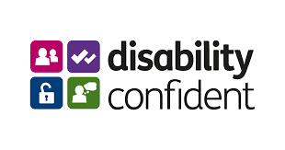 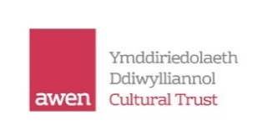

**Dear Valued Employer**

**How diverse is your business?**

**We would like to invite you to join us and learn more about recruiting and retaining a wealth of untapped talent your business could be missing out on**.

People with a health condition in this country make up a dedicated, loyal and skilled workforce who could help your business in a time of increased competition for good employees, and avoid you getting caught out by skills shortages.

# Date: 18th May 10.00 -12noon

**Venue: Bryngarw House, Bryngarw Country Park, Brynmenyn, Bridgend, CF32 8UU**

This event, organised between Department for Work & Pensions (DWP) and Business Wales, and hosted by Awen Cultural Trust who are a Level 3 [Leader] Disability Confident accredited organisation, is designed to showcase the business benefits employers like yourself could be missing out on by not employing people with health conditions.

***“We are proud to be a Disability Confident Leading organisation and are committed to building a diverse, inclusive workforce, where everyone feels a sense of belonging. Accessibility is high on the agenda at present and at Awen we are changing the way we work to ensure our selection processes are as accessible as possible including, providing questions 15 mins prior to interview, considering video applications and creating accessibility plans for our main venues and publishing them on our website”.*** *Helen Cook, Head of People, Awen Cultural* Trust

Terry Mills and Huw Chance from the Welsh Government look forward to the upcoming event. As disabled people’s employment champions they are both keen to tell of the work they are currently involved in.

At the event you will be encouraged to sign up to the Disability Confident scheme. There are more and more people who look at the purpose and values of Companies including any awards that the Company has been issued. When signing up to Disability Confident, you will receive logos to go on your website and stationary which will help you stand out from your competitors

You will hear testimonials from motivational speakers, and be able to talk to qualified staff from the Department of Work and Pensions, Business Wales and Welsh Government.

Don't miss out on this valuable pool of potential skills and the financial, operational and social benefits that being a Disability Confident employer can bring. Join us at our ‘How diverse is your Business?’ event

Refreshments will be provided upon arrival

**Please book your space by e-mailing the form below to:** [**bridgendmarketstreet.recruitment@dwp.gov.uk**](mailto:bridgendmarketstreet.recruitment@dwp.gov.uk)

When you have confirmed your attendance, a further email will be issued nearer the time with joining details.

Yours sincerely,

Gethin Charles Lisa James-Gillum

Employer Adviser Specialist HR/Disabled People’s Employment Adviser

DWP Business Wales

**How diverse is your business?**

**Bryngarw House, Bryngarw Country Park, Brynmenyn, Bridgend, CF32 8UU**

**May 18th 2023 10am – 12noon**

I/my colleague…………….……………….. (insert name) will be attending ‘How diverse is your business?’

I/my colleague will be representing…………….……………(insert name of Company)

Email address ……………………………………………..

Telephone number: ……………………………………….

